Step 1: Necessary Downloads

UK Data Service Accounts
Create an account on UK Data Service, then create a new project to assign the dataset. Any dataset that we browse on UK Data Service will need to be assigned to a project. Hence this step. Once done, select the browse data catalogue option and search for “ Active Lives Survey”. You will be provided with various datasets. Select the one that you need.

Download Dynamic Code
In the ALS report, a link to a Github account of Atharva Atul Joshi is provided. Upon selecting it, you will see “.ipynb” file (which we will be referring to as notebook from here on). Download that file and save it in your computer

Platform to execute the dynamic code:
Google Collab: Search the same name on google, sign up with your gmail and click on new notebook. A tab with some blank cells will appear. Now go to upper left corner and open a new notebook which you have saved in the previous step.

Step 2: Executing the Dynamic Code
While instructions and comments on how to execute the code are given in the notebook, I am writing down some fundamentals that any ALS/ RFU researchers need to keep in mind.
- The notebook consists of various functions. So, the part where you will see the words “def” followed by some phrase, is called as creation of that function. All the functions are already created in the notebook and you as a researcher will just be implementing the functions.
- Every function has some parameters that are defined while creating the function. These parameters are the inputs that are needed for that function to work. While implementing any function, once you call the function (write the name of the function, like, function_1(), we need to pass these parameters inside the round brackets, function_1(input_parameter_1= , input_parameter_2= ).
- A trick to see what input parameters are there inside a function, call the function, place the cursor inside the curly bracket and press “shift+tab”
- The code is executed cell by cell. So, to run a cell, you can either just click on the run symbol in the side of that cell or you can place your cursor on the cell and press “shift+enter”.

STEP 3: User Inputs
There are some codes where the researchers will have to do some selections and assign a variable to those selections. It is important to do this as these variables are also used as input parameters to some functions. The places where they will have to do this is mentioned in the code book/ this file.

Function 1:
The load_file function is a versatile utility that loads data from various file types, including SPSS (.sav), CSV (.csv), and Excel (.xls, .xlsx). It checks if the specified file exists and then reads the file based on its extension. For Excel files, it supports loading a specific sheet by name, multiple sheets by their indices, or all sheets as a dictionary. Starting from 0, sheet indices can be specified in form of a list (inside square brackets) when implementing the function.
Just replace the path of the location where you saved the dataset inside the inverted commas.

Function 2: Using Regular Expressions (RegEx)
Once we have loaded the dataset, we need to understand that ALS file has plenty of variables. So we need to narrow it down according to the sport and some generic variables. That is why we will RegEx. Regular expression has been used to find relevant variables defined by the user. We need to give a pattern for Regex, which is show below in the first 4 lines. Next we will call the next function find_columns() and store it in respective variables.
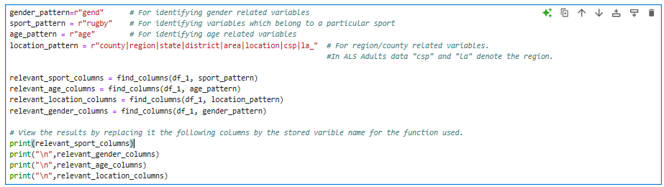
When you print the above variables you will get the resepective variables in front of you to select from.

User Input:
There will be some generic variables that are present in the dataset and mostly they are in the beginning columns itself. Add any column that you as a researcher deem fit. Select the one you find the best and replace that variable name in the quotes below and name it accordingly as follows
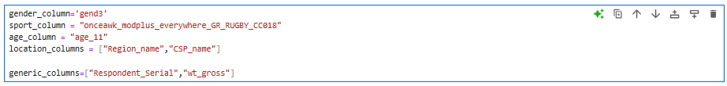

Function 3: filter_desired_column()
All the previously defined columns will get fitered using this function. The function is called and implemented as follows:

Function 4: map_numerical_data_to_labels()
Function 3: Map numerical labels to actual names.Usually in datasets, some categorical variables will be represented using numbers. We need to convert it to category usingmapping function of Python.
Step 1: Annotate the numerical value (which is there in the dataset) as key and,the actual name (which you can find in data dictionaries) as a value in dictionary format (key:value), as below
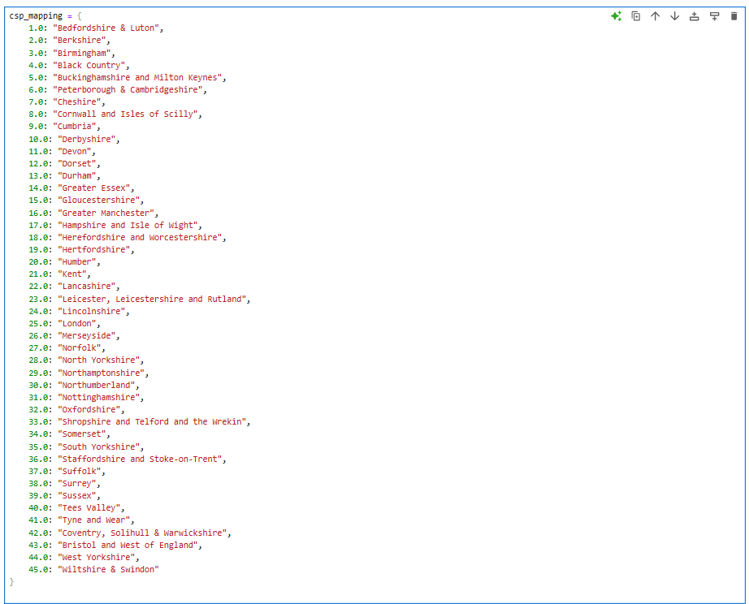
Step 2: Replace the names of variables in the below function

Seperating the age column (Optional Step)
The variable in ALS datasets that represents age is age_11, which has values from age 5 to 16. So this code cell just converts these values from one row to each age group having separate columns. This step is done to just align the dataset like that of RFU.

Function 5: Preprocessing Functions
These are the common functions for filtering values in a column. You can ignore if it doesn't apply to you or your dataset.
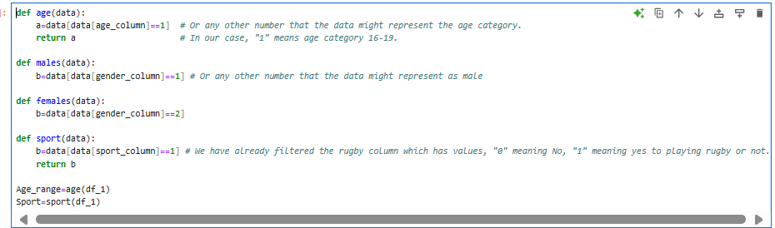

Function 6: convert to desired format
If you have many datasets for different years you will need to save your filtered datasets properly, which will be case for ALS datasets. We will use the first function again to extract the desired files for further analysis and preprocessing. If it doesn't apply to you, you can skip to the next step.
The acceptable file formats are csv, xlsx.
Now the above 6 functions will be used for all the ALS files that we want to analyse and by the virtue of function 6, it gets stored into the desired format. The next functions will be analyzing all the filtered and stored ALS files. If you have an RFU dataset, start from the next function.

Function 7 = Function 1.
As we have stored the datasets, we will use the function 1 to import those into our code. The words in red are the files names (file paths) which will be changed by you as a user.
“#” ensures that line is not included while the code is been run. You can unhash the next lines according to the number of files you will be importing.

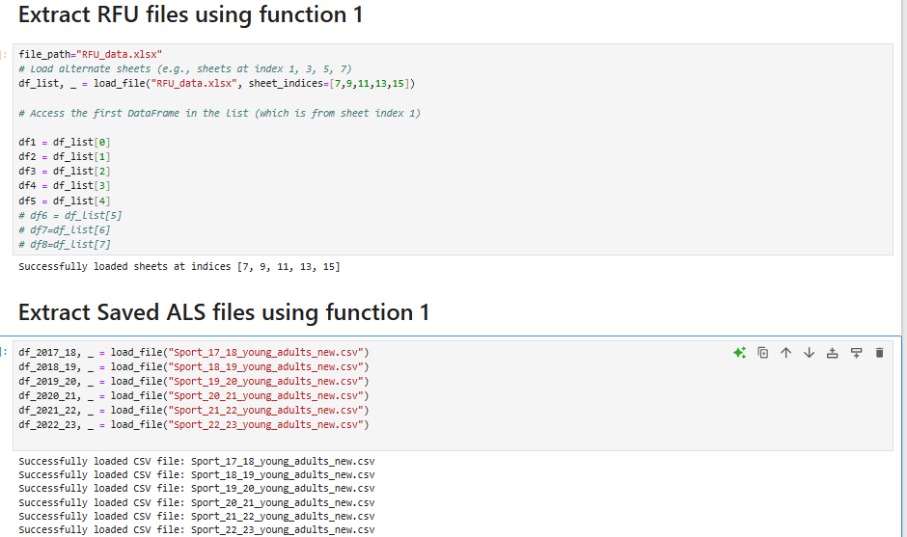

Function 8: weight_calc() [Only for ALS Data],[Skip for RFU]
The whole ALS survey is based on the sample and hence we multiply the respective respondents with the weight column given in the ALS data.
Sport column variable (replace with actual column name). sport_column = "Sport_Column_Name”

Function 9: split_by_gender()
Function to create male & female subsets. Just know you have to give the male code, female code according to your dataset. Every years’ dataset has combination of males and females, that’s why we call the function in this way.
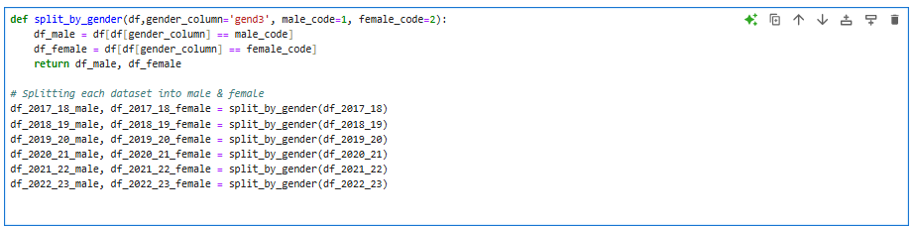

Function 10: Plot year-on-year trend for ALS data
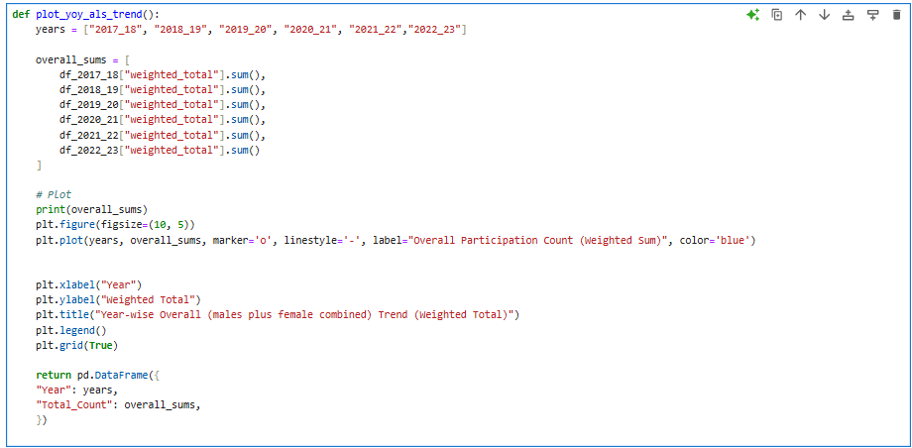
The above function has been created now below is the way to call that function.
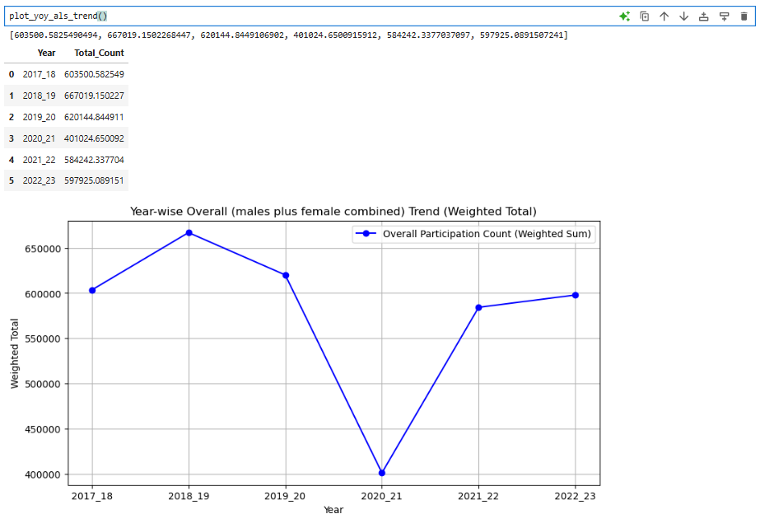

Function 11: plot_weighted_gender_trend()
Same function as above but separated for males and females

Function 12: plot_total_participation()
Same as ALS, but this function takes into account the RFU data. Gives the trend for overall participation till the age of 17.

Function 13: Year-on-Year RFU plots
Same as ALS, but this function takes into account the RFU data for genderwise y-o-y trend

Function 14: group_by_columns()
A very important function that helps the user group across categories like age, region

Function 15: Plot Category trends
After applying the above function, we have essentially grouped the the data according to the region or the age and now we will be looking at some insightful trends with the help of this function. These insights can be the largest counties playing Rugby or the counties with best percentage growth across the years and vice versa.
This function will be used for all the sections that are shown in the picture below
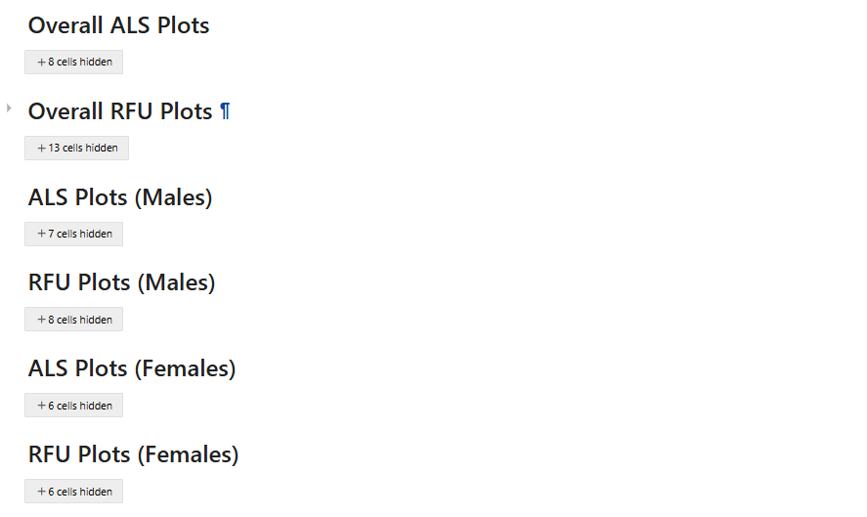

Function 16,17,18: For agewise trends in ALS and RFU datasets
The next two sections shown below will be used to plot agewise analysis. The same group by and plot participation trend function
